Chemistry Lesson Plan: Mole Concept
Intern | Abdulrahman Albabakri
ECAE ID | 025302
School-based Mentor | Mr. Hatem
ECAE Faculty Mentor | Dr. Dean
Subject | Chemistry
Grade | 10 ADV
Lesson Title | Measuring Matter (The Mole Unit)
Lesson Time | One hour
Date | Term 2 2026

Learning objectives
- Define the mole as the SI base unit used to measure the amount of a substance.
- Relate the value of Avogadro’s number (6.02×10²³) to the counting of representative particles such as atoms, molecules, and formula units.
- Perform basic conversions between amount in moles (n) and number of particles

Materials/ resources needed
- Smartboard, TED-Ed Video Link, PowerPoint presentation for visual cues.
- Electronic balances, Ziploc bags, Weighing boats.
- Candies (M&Ms, Skittles) or Beans (Lentils, Pintos) to represent particles.
- Periodic Tables, Scientific Calculators, "Mole Map" scaffolds.
- Worksheet

Teaching and Learning Sequence
Introduction
Links to Prior Learning:
- The students understand that elements are composed of atoms with unique atomic numbers and masses (Electrons in Atoms, Lesson 1 & 2).
- Students can locate elements on the periodic table and identify their atomic mass (The Periodic Table, Lesson 1).
- Students recognize chemical formulas for ionic and covalent compounds (Ionic Compounds & Metals; Covalent Bonding).

Substance Type | Representative Particle | Context/Example
Atomic Element | Atom | Pure Gold (Au) or Copper (Cu)
Diatomic Element | Molecule | Oxygen Gas (O₂) or Nitrogen Gas (N₂)
Covalent Compound | Molecule | Water (H₂O) or Carbon Dioxide (CO₂)
Ionic Compound | Formula Unit | Sodium Chloride (NaCl)
The teacher begins by anchoring the new learning in students' existing knowledge of mass and weight, clarifying that while weight is a measure of gravitational force, mass—and by extension the mole—is a measure of the amount of matter.

To facilitate peer teaching and ensure that all students, regardless of their initial achievement level, are challenged and supported, the class is divided into mixed-ability groups. The class of 12 students includes 3 above-level students, 6 on-level students, and 3 below-level students. The groupings are designed to encourage social construction of knowledge, a key component of the Inspire Science pedagogy.

The lesson is divided into five distinct parts, each meticulously timed to ensure that the learning outcomes are achievable within a standard session.
Body
Part 1: Starter and Introduction (10 Minutes)

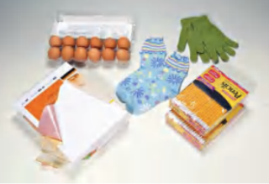
- The teacher introduces the learning outcomes and contextualizes the lesson as the start of the "Mole Journey".
- To assess prior knowledge, the teacher initiates a brainstorming session where students list words that represent specific quantities (e.g., couple = 2, dozen = 12, ream = 500, gross = 144).
- This activity serves as a "Let's Recall" segment, checking the students' comfort with numerical bundling.
- The teacher then poses a framing question: "If you were a chemist needing to react exactly one atom of oxygen with two atoms of hydrogen to make water, why would it be impossible to count them out?".

Part 2: Engage and Discuss (10 Minutes)

- The teacher uses a high-impact visual stimulus by playing the TED-Ed video "How Big is a Mole?". How Big is a Mole
- This video provides critical analogies to help students visualize the enormity of (6.02×10²³), such as a mole of donuts covering the Earth or a mole of basketballs creating a new planet.
- After the video, the teacher leads a guided discussion where students must summarize the magnitude of Avogadro's number.
- The teacher reinforces the concept that the mole is a counting unit, not a physical property like density or volume.

Part 3: Exploration through Inquiry (20 Minutes)

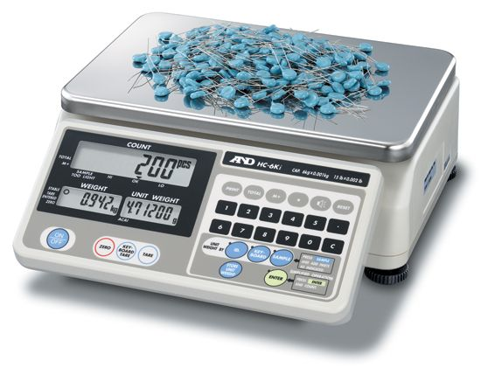
In this phase, students engage in a hands-on lab activity designed to model the relationship between a count and a mass. Each group is given three bags of "representative particles" (different types of candies or beans, such as M&Ms, Skittles, and Jellybeans).
- Students are told that "one bundle" is equal to exactly 20 items.
- Each group must find the mass of "one bundle" for each candy type using an electronic balance.
- Students record their data in a table, observing that while the count is the same (20 items), the masses are different.
- The teacher prompts: "If a mole of Lead is much heavier than a mole of Carbon, does that mean the mole of Lead has more atoms?".
- Groups must derive a method to provide the teacher with "5 bundles" of a candy without counting them individually, using the mass-per-bundle ratio.

Part 4: Elaborate and Explain (10 Minutes)

- The teacher transitions the students from the concrete "bundle" unit to the abstract "mole" unit.
- Using the smartboard, the teacher introduces the formal definition of the mole and Avogadro's number: (6.02×10²³) particles per mole.
- Mathematical Modeling: The teacher demonstrates the two primary conversion formulas:
To find particles
$$\frac{6.022×{10}^{23}\text{ particles}}{1\text{ mole}}$$To find moles
$$\frac{1\text{ mole}}{6.022×{10}^{23}\text{ particles}}$$

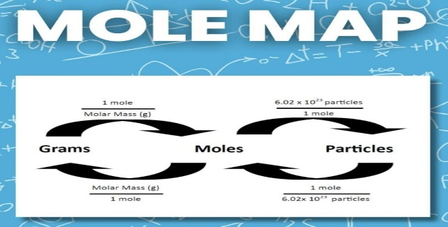
- Guided Practice: Students use their periodic tables and calculators to solve Example Problem 10.1 from the Worksheet, such as converting $4.50×{10}^{24}$atoms of Zinc into moles. $\text{moles of Zn}=4.50×{10}^{24}\text{ atoms Zn}×\frac{1\text{ mole Zn}}{6.02×{10}^{23}\text{ atoms Zn}}$
- The teacher roams the class, providing scaffolding for below-level students using "Mole Map" graphic organizers.

Closure
Part 5: Consolidation and Closure (10 Minutes)

- To consolidate learning, students solve the worksheet where they must correctly solve a conversion problem to advance through a specialized path on their worksheet. This worksheet ensures high engagement and allows for immediate formative assessment.
- The teacher then asks a higher-order "brain-tackling" question: "In the pharmaceutical industry in the UAE, why is measuring medicine in moles more accurate than measuring it in grams for treating specific cellular receptors?".
- The lesson concludes with an independent "Exit Ticket" on the Whiteboard where students must calculate one mole-to-particle conversion to demonstrate mastery of the learning outcomes.

Assessment
Student achievement is measured through a combination of observable actions and written performance.
  - LO 1 & 2 Assessment: Verified through group discussions during the "Engage" phase and the ability to define the unit during the "Starter" recap.
  - LO 3 Assessment: Measured via the "Guided Practice" worksheets and the independent "Exit Ticket" calculation.

Worksheet 1 : Converting between Moles and Particles:
1 mole of representative particles = (6.02×10²³) representative particles
You can write two different conversion factors then use the correct one to make the conversion.
To find particles
$$\frac{6.022×{10}^{23}\text{ particles}}{1\text{ mole}}$$To find moles
$$\frac{1\text{ mole}}{6.022×{10}^{23}\text{ particles}}$$
Practice:
- How many particles of sucrose are in 3.50 mol of sucrose?

- Determine the number of Zn atoms in 2.50 mol of Zn.

- Calculate the number of moles of zinc that contain $4.50×{10}^{24}$ atoms.

- Calculate the number of molecules in 11.5 mol of water (H2O).

- Silver nitrate (AgNO3) is used to make several different silver halides used in photographic films.How many formula units of AgNO3 are there in 3.25 mol of AgNO3?

- Calculate the number of oxygen atoms in 5.0 mol of oxygen molecules. Oxygen is a diatomic molecule, O2.

- Identify the representative particle for each formula and convert the given number of representative particles to moles. $3.75×{10}^{24}{\text{ CO}}_{2}$

